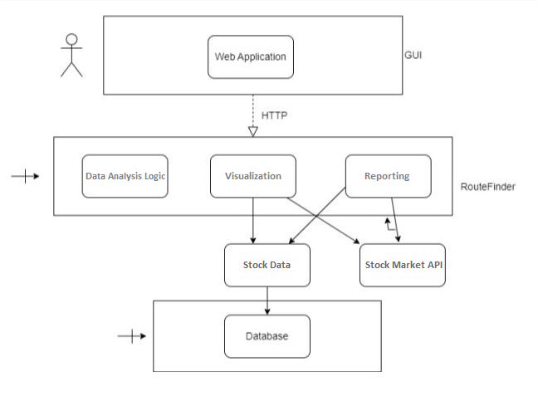***Извршен модел***